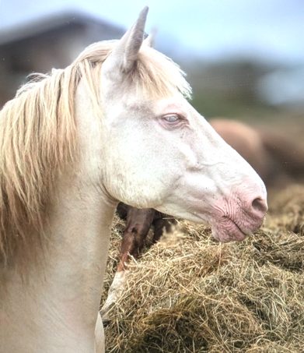
Briarpatch Sea Hawk – ‘ Storm’
Selah Victor Allen x Caylyn Bold as Brass

14.1 Perlino Stallion. Foundation bred
Stands by Frozen AI only

'Briarpatch Sea Hawk carries blood lines which are rare and unusual for the UK being UK born of parents imported from the Crown Oaks/Selah stud of Cindy Lang. Sea Hawk's Sire line is Lambert, line bred to Criterion and dam line is Western Working. Sea Hawk has colour tested AaEeCrCr and is available by frozen semen only, via StallionAI at the great value fee of £150 (plus StallionAI and your own vets fees.
Photo credits Ashleigh and Susan Buck.
Further details from stevedotbayston@gmail.com or mobile 07973 190987.'

