BMHS
MONNINGTON
EASTER
CLINIC

with
MIKE GOEBIG AND DWAYNE KNOWLES
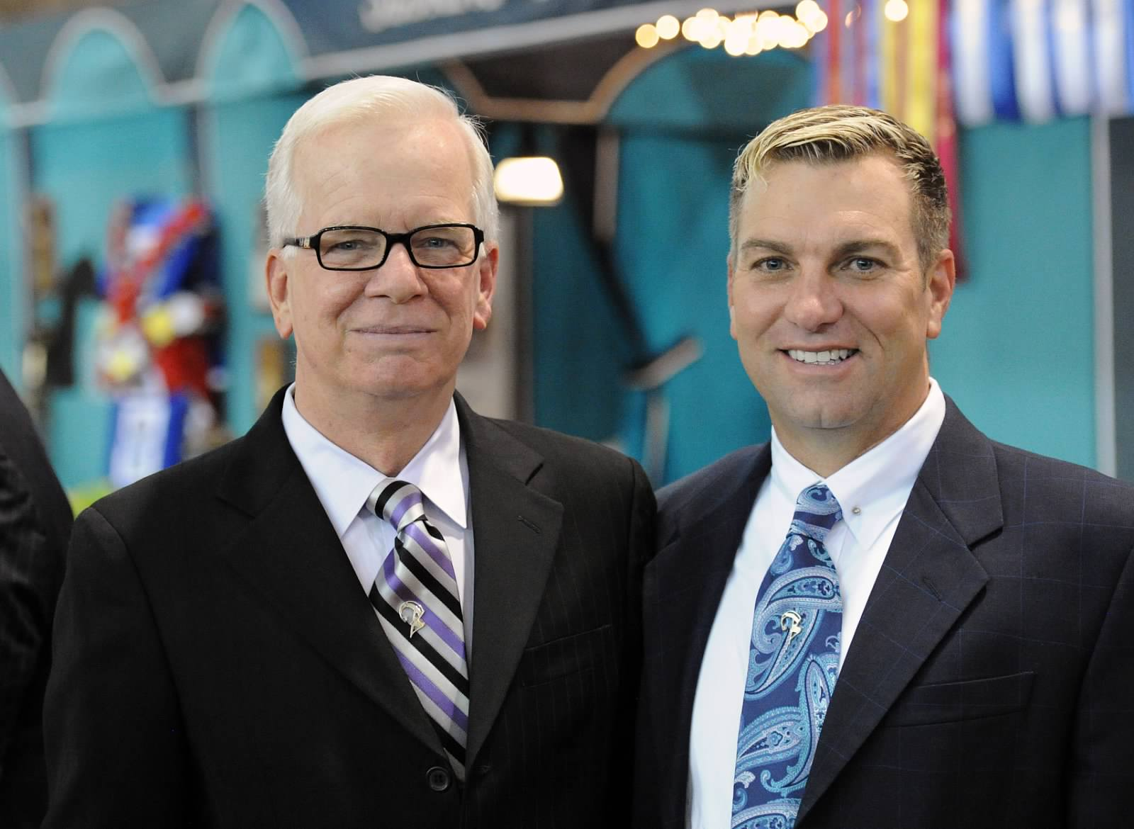

7th – 10th April 2023

MONNINGTON COURT, MONNINGTON-ON-WYE, HEREFORD, HR4 7NL TEL: 01981 500488

CALENDAR OF
EVENTS 2023

6th – 10th April Easter Clinic
2023 Monnington Court, Hereford, HR4 7NL

28th May 2023 USAUK Annual Championship Show
Moreton Morrell, Warwickshire

8th - 10th June Royal Cornwall Show
2023 Wadebridge, Cornwall

20th/21st June Cheshire County Show
2023 Knutsford, Cheshire

25th June 2023 Foreign Breeds Solstice Show
White Horse Farm, Harvel, Kent, DE13 0UE

25th June 2023 HOPE Summer Show
Weston Lawns, Bedworth, Coventry, CV12 9JA

7th – 9th July Kent County Show
2023 Detling, Kent

20th August 2023 HOPE Championship Show
Rugby Riding Club

10th September APHS Foreign Breed National Finals
2023 Pachesham EC, Surry KT22 0AL

29th September - VHS National Championships
1st October 2023 Arena UK, Grantham, NG32 2E

PLEASE SEE THE BMHS 2023 CALENDAR PAGE FOR FURTHER DETAILS OF FOREIGN BREEDS CLASSES TAKING PLACE THROUGHOUT THE SEASON.

www.morganhorse.org.uk
WELCOME

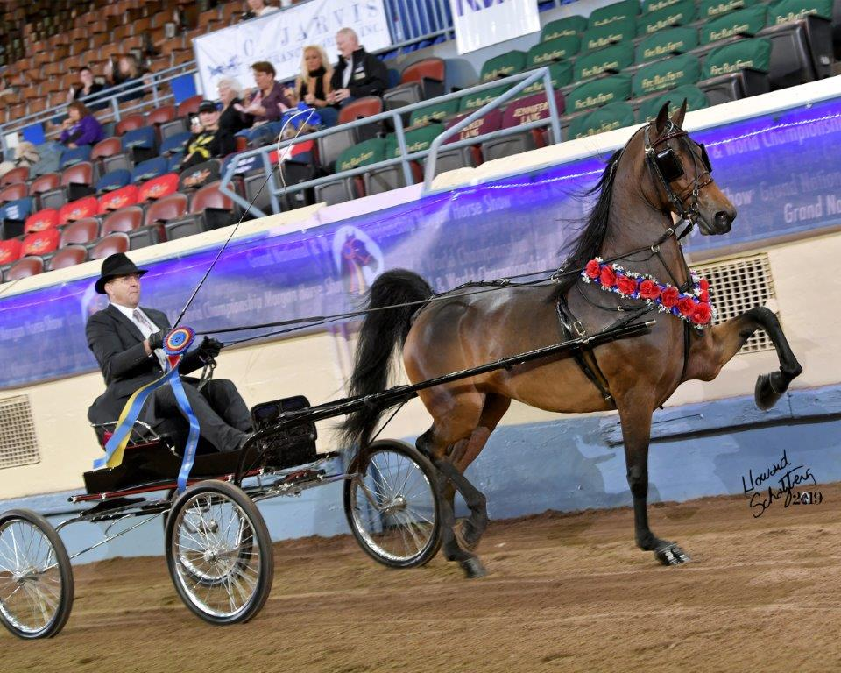

to the BMHS 2023 Easter Event. We are more than ready to see you all to kick off the 2023 season. Whatever your discipline or interest we can offer help and advice in an ideal learning environment.

We are delighted to have Mike Goebig and Dwayne Knowles join us AGAIN this year. It is an utter privilege to have the wealth of experience and knowledge they bring with them at our disposal. We also have the pleasure of welcoming C.A.Tony Lee III, Vice President of AMHA and Erica Eulau, AMHA Registrar to this event.

Mike and Dwayne enjoyed another fantastic show season in 2022. They literally blew the competition out of the water at Grand Nationals with World Champion after World Champion. When you see the quality of horses that Broadmoor put in the ring, it simply takes your breath away. If we can match anything remotely close to the standards these two trainers achieve then we will be flying super high. Let’s make the very most of our time with them!
We can’t wait to see you all.

The BMHS Board

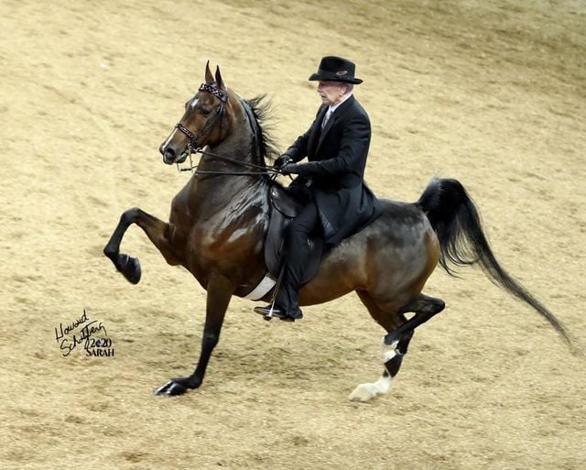
FRIDAY 7th APRIL 2023
9.30am Coffee and Introductions

10.00am Lessons

1.00pm LUNCH

2.30pm Lessons

3.30pm ALL YOU NEED TO KNOW ABOUT
EQUINE PHYSIOTHERAPY- Laura Bent will
talk us through Equine Physiotherapy and
give us some simple but effective tips that can ensure our equine friends are feeling great and
ready to work. INDOOR SCHOOL

4.30pm History of the AMHA Registry with AMHA Registrar Erica Eulau Richards. BUTT HOUSE

5.00pm Lessons end

7.30pm BUTT HOUSE BINGO AND PIZZA!
Join us for a night of Bingo in the Butt House. ENJOY fabulous homemade pizza. Bring your favourite tipple and your dabber! £10 per person! Eyes down at 8pm!!! Cash Prizes and more!!
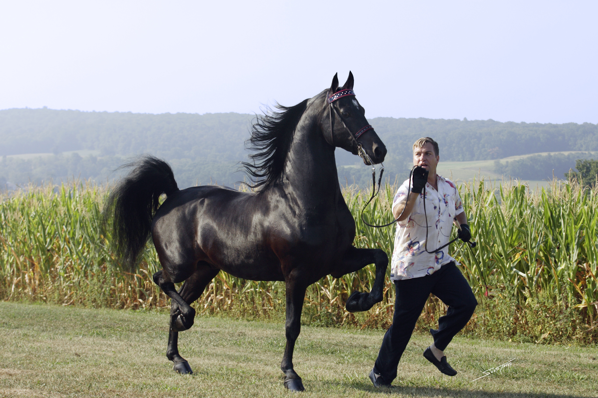
SATURDAY 8th APRIL 2023

10.00am Lessons

1.00pm LUNCH

2.30pm Lessons

2.30pm EQUINE NUTRITION – We welcome Jenny
Fitzpatrick, an Equine Consultant from Castle Feeds. Jenny will give us bit of an insight into how we should approach the nutritional needs for our Morgans! BUTT HOUSE

5.00pm BMHS AGM – have your say in the running of YOUR Society. Now is your chance to make a difference. BUTT HOUSE

7.00pm Fish and Chip Supper - freshly cooked on our doorstep. Relax in the Butt House with a drink whilst dinner is prepared and enjoy a night with friends old and new.

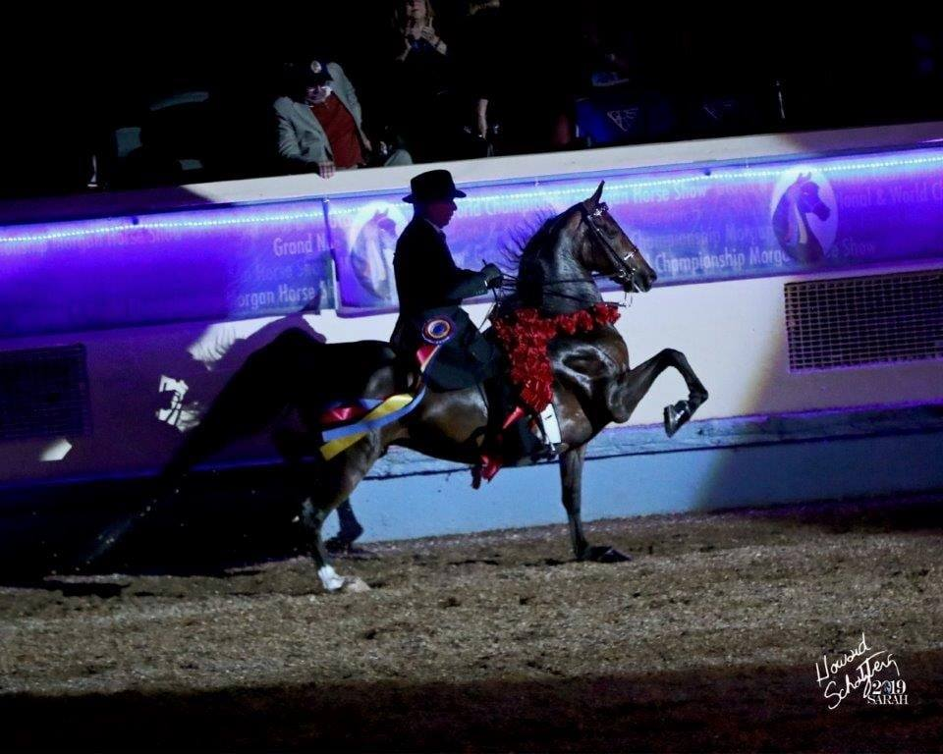

SUNDAY 9th APRIL 2023

9.00am Lessons

12.00pm BARB’S BONNET COMPETITION. A perfect way to remember our wonderful ‘Barb’ and keep her spirit firmly with us. Make a bonnet, decorate your horse and yourself and enjoy a stylish ride/ drive up Monnington Walk where Hot Cross Buns and Mr B’s Rocket Fuel Cider will be served. Prize for the Best Bonnet.

1.00pm LUNCH

2.30pm Lessons

3.30pm TRAIL CLASS – open to all! Morgans love
to explore new things! Whether you’re a
serious competitor or just want to see how
far you can get! Ribbons to 6th place. Open
and Youth (Leadline entries welcome) GREEN

7.00pm Dinner at The Bay Horse, Kings Acre Road,
Hereford.Please complete the Pre-Order Form.

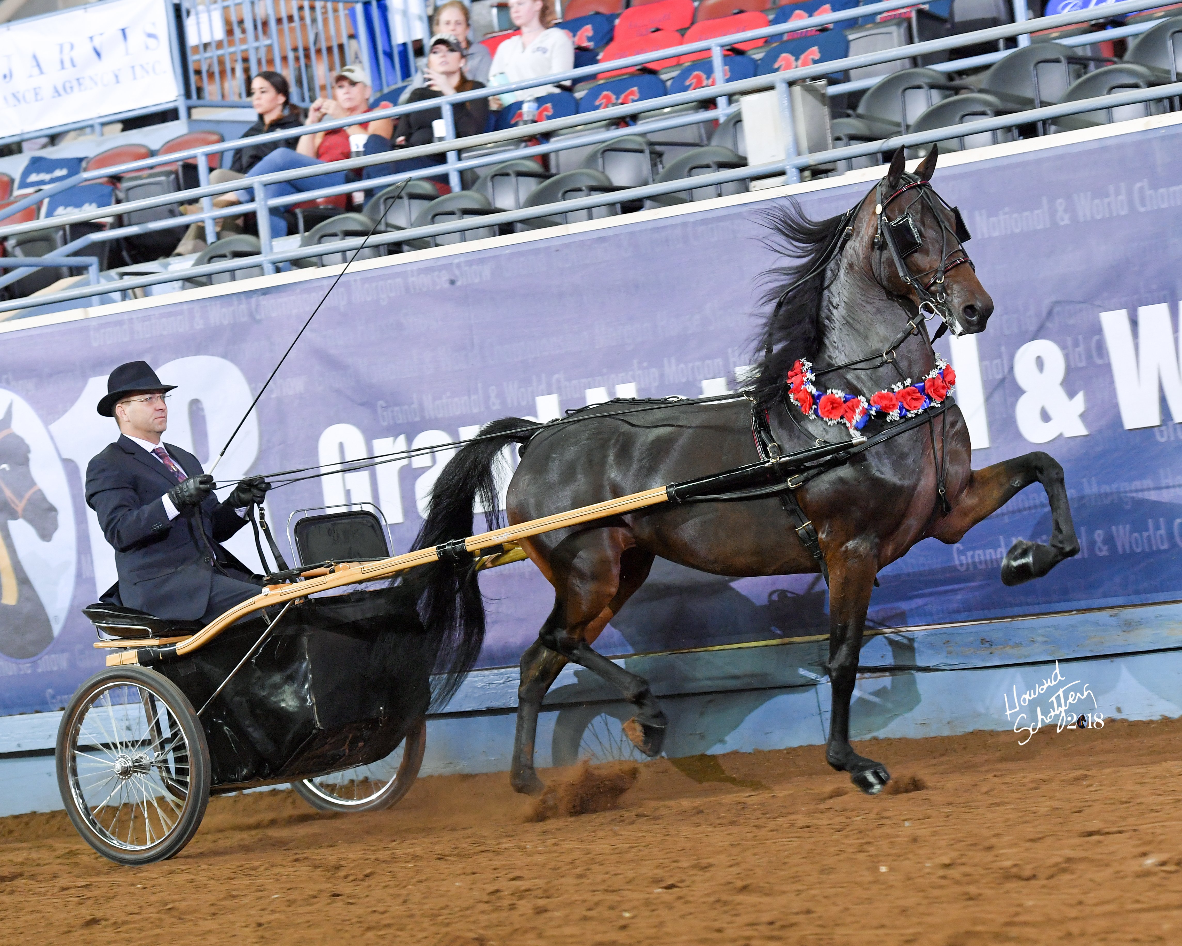
MONDAY 10th APRIL 2023

9.00am Lessons

11.30pm ACADEMY CLASS SHOW AGAIN! – I know we
do this every time but it is such a learning
curve for us and gives us all the chance to ride
in the show ring without the pressure of
complete show tack or clothes, though if you
want to test out an outfit and your show bridle
then it is a perfect opportunity. We will run
an In Hand Class, a Walk, Trot Ridden Class and
finally a Walk, Trot, Canter Ridden Class. All
divisions will compete together in each class and
the classes will be placed but will then be
followed by a discussion on why the class was
placed that way and helpful tips will be given on
how you could enhance your performance for
next time. Training tack permitted with neat and
correct riding attire.

1.30pm LUNCH

3.00pm CLINIC ENDS

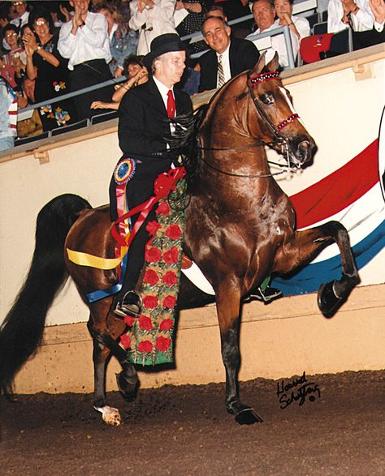

A FEW RULES……….

Dogs welcome but should be kept on a lead. No dogs in the Butt House please.
No smoking on the Yard. Smoking is permitted outside the Butt House.
Tents/Caravans/Motorhomes more than welcome. Sorry no accommodation available on site. Limited Electric Hook up available.

Local B+ B’s

Dairy House Farm, Monnington 01981 400143
The Swan At Letton, Letton 01544 327870
Red Ley Farm, Letton 01981 500628
Mellington House, Weobley 01544 318537
Ye Olde Salutation, Weobley 01544 318443
The Bay Horse, Hereford 01432 273351

