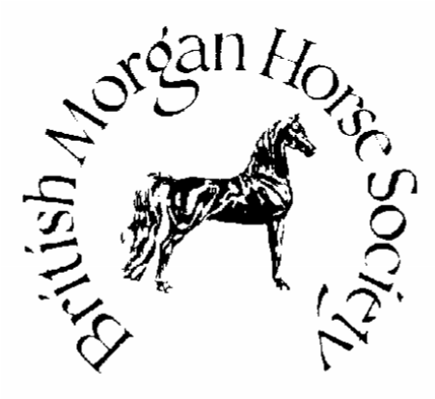

BRITISH MORGAN HORSE SOCIETY

Monnington Court

Monnington-on-Wye

Hereford HR4 7NL

Tel: 01981 500488

# MEMBERSHIP APPLICATION FORM 2025

NOTES:

1. Please tick the relevant box for owner/non owner status.
2. Overseas Members are those who reside outside the United Kingdom and do not wish to vote.

PLEASE FILL IN ONE FORM PER PERSON.

1. ADULT MEMBER OWNER NON OWNER Annual Fee £25.00

|  |  |  |
| --- | --- | --- |
| 2. JOINT ADULT MEMBERSHIP – 2 adults/ one address, will receive one set of |  |  |
| Correspondence i.e newsletter/magazine  Joint Adult 1.................................. Joint Adult 2................................... |  | Annual Fee £40.00 |
| 3. OVERSEAS MEMBER |  | Annual Fee £25.00 |

4. YOUTH MEMBER - 21 years or under on 1st January OWNER NON OWNER Annual Fee £15.00

|  |  |  |  |  |
| --- | --- | --- | --- | --- |
|  |  |  |  |  |
| 5. OWNER OF A REGISTERED PART-BRED - Non voting Member |  |  |  | Annual Fee £25.00 |

BACS PAYMENT INFORMATION: ACCOUNT NO : 00129763 SORT CODE: 20-53-22

IF PAYING MEMBERSHIP BY BACS PLEASE BE SURE TO INCLUDE YOUR SURNAME IN THE PAYMENT

DETAILS. A MEMBERSHIP FORM STILL NEEDS TO BE COMPLETED AND RETURNED TO THE ADMIN

OFFICE. CHEQUES SHOULD BE MADE PAYABLE TO: BMHS

I WISH TO APPLY FOR:……………………………………………………MEMBERSHIP TOTAL £________

NAME:…………………………………………………………………………D.O.B(YOUTH MEMBER)………….

ADDRESS............................................................................................................................................................................

..............................................................................................................................................................................................

POSTCODE:...........................TEL...........................................E-MAIL:...........................................................................

SIGNED........................................(Member(s)/Parent/Guardian if under 18yrs) Date…………………………………..

(I agree to abide by the rules of the BMHS, BMHSY and agree to my contact details being supplied to Officers of the BMHS)

THE ONLY OFFICIAL ORGANISATION OF THE BRITISH MORGAN HORSE TO HAVE RECIPROCITY WITH THE AMHA

_______________________________________________________________

EMAIL; [admin@morganhorse.org.uk](mailto:admin@morganhorse.org.uk)